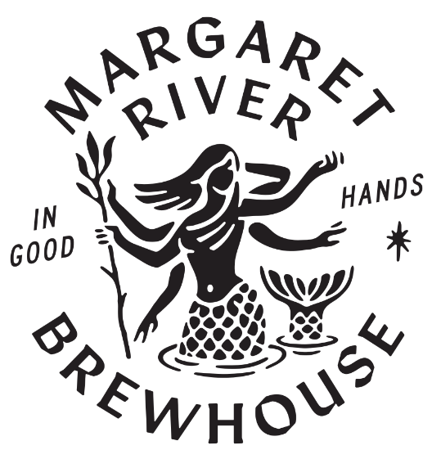

BACKYARD BREWING TOURNAMENT 2020
TOURNAMENT RULES
- TOURNAMENT REGISTRATION

  - Entrants must complete the Entry Form to register.
  - Closing Date for submitting the form is Registrations July 31, 2020
  - Late entries received by post or email after this time and date will not be accepted.
  - One Entry form per competitor.
  - Entry forms can be down loaded from our website www.margaretriverbrewhouse.com.au, picked up from the venue or emailed to you – call 97572614.
  - Entry forms can be posted to PO Box 2310 Margaret River 6285, dropped off at the BREWHOUSE at 35 Bussell Highway, Margaret River or emailed to info@mrbrewhouse.com.au
  - A maximum of 2 beers may be entered by a competitor.
  - Brewers can submit as a team or group of more than 1 person.
  - The Tournament is not available to employees of BREWHOUSE Margaret River or brewers working in commercial or craft breweries.
  - Entrants must reside in Western Australia.

- ENTRIES AND JUDGING

  - Entries must show:
    - the name of the beer,
    - the alcohol content and
    - the style of the beer as per the Australian Amateur Brewing Competition guidelines using this link www.aabc.org.au.

These should all be shown on labels on the submitted beers.

  - Each beer entry shall be submitted in either 1x750ml king brown or other bottle or 2 x 500ml container or a mini keg per beer.
  - All entries must be received at the Brewhouse between 10am Thursday August 20 and 7pm Sunday August 23.
  - A Perth drop off point will be available during some of this time.
  - Awards will be announced at the Brewhouse on Friday August 28 at the awards night at which tournament participants will receive priority reservations

  - Awards will comprise:
1st Prize (Best Beer in Tournament): Winning Beer to be brewed at the Brewhouse Brewery with help from our head brewer and put on tap at our bar. Plus 1 free pint every time the winning brewer comes to the Brewhouse (maximum of 1 per day) Plus a $250 voucher to spend at our venue
2nd Prize: A $100 gift card for lunch/dinner at the Brewhouse along with Brewhouse MR merch.
3rd Prize: A $50 gift card for lunch/dinner at the Brewhouse along with Brewhouse MR merch.

  - Gold, Silver and Bronze medals will be issued as per the following criteria:

APPEARANCE……………………Max 3.0 points
Colour, Carbonation/foam characteristics
AROMA ……………………………Max 5.0 points
Positive characteristics, Aroma faults
FLAVOUR………………………….Max 6.0 points
General characteristics
Bitterness
Fermentation products
Flavour faults
STYLE .......................................Max 3.0 points
Appropriate for Class
TECHNICAL QUALITY ..............Max 3.0 points
Balance, drinkability, Absence of major faults

Awards will be made as follows:
Gold Award………. .............. 17.0 points +
Silver Award……… .............. 15.5 to 16.9 points
Bronze Award……. .............. 14.0 to 15.4 points

BACKYARD BREWING TOURNAMENT
ENTRY FORM 2020

ENTRIES FORMS TO BE SUBMITTED BY JULY 31ST 2020
Entry forms can be posted to PO Box 2310 Margaret River 6285, dropped off at our brewpub at 35 Bussell Highway, Margaret River or emailed to info@brewhousemargaretriver.com
Brewers Name:___________________________________________________________
Address:________________________________________________________________________
Mobile or Home Ph No.___________________________________________________________
Email Address:__________________________________________________________________

Beer Details
Beer Name | Beer Style – as per 2019 AABC Style Guidelines http://www.aabc.org.au/docs/AABC2019StyleGuidelines.pdf | Reference No. from AABC Guideline | Alcohol Content (%)

REMEMBER
Entry Forms to be submitted by JULY 31, 2020 and
Beers to be submitted by Sunday AUGUST 23, 2020 (7pm)

